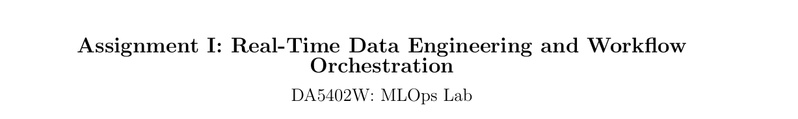
Details :
Roll Number : DA25M502
Name : Amardeep Kumar
Software Requirements :
Docker
Airflow : 3.0.2

Part C
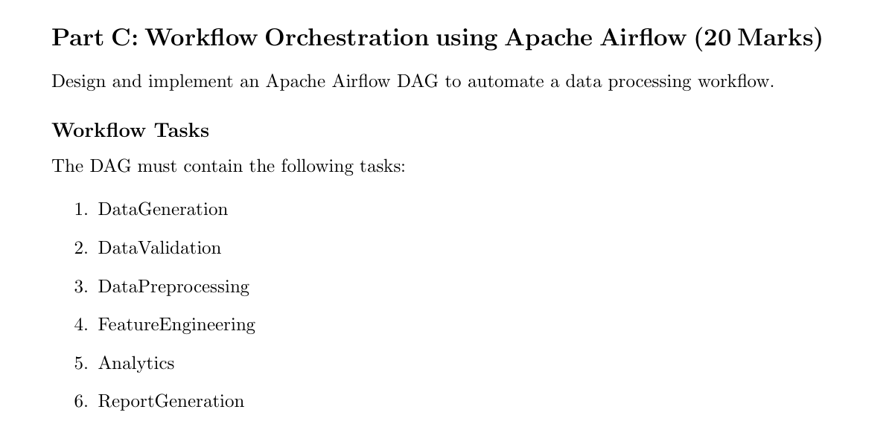
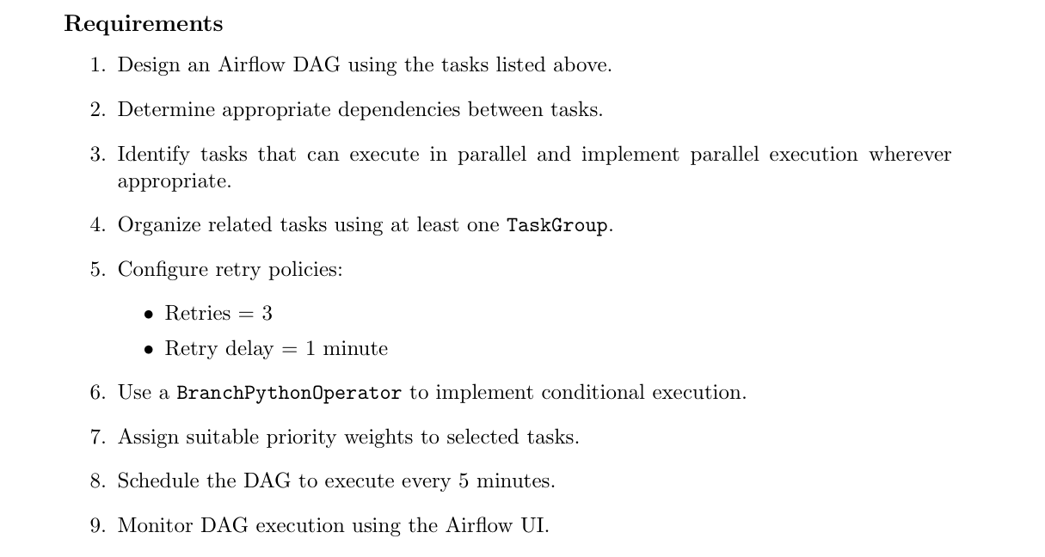
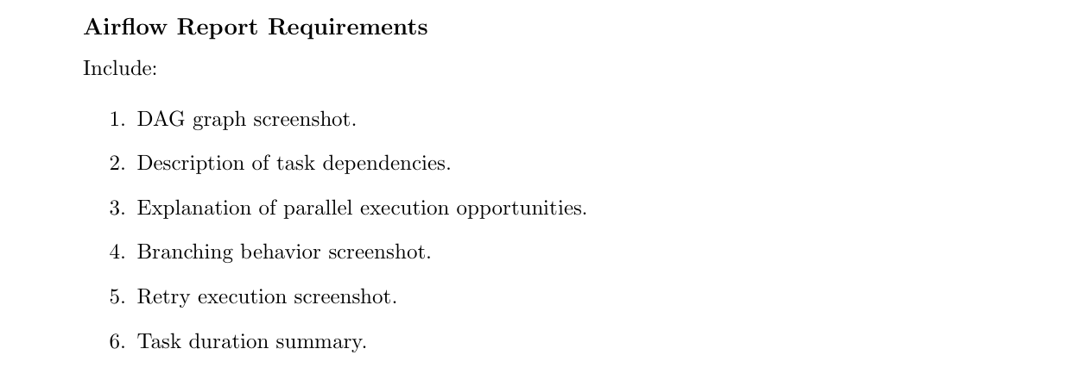
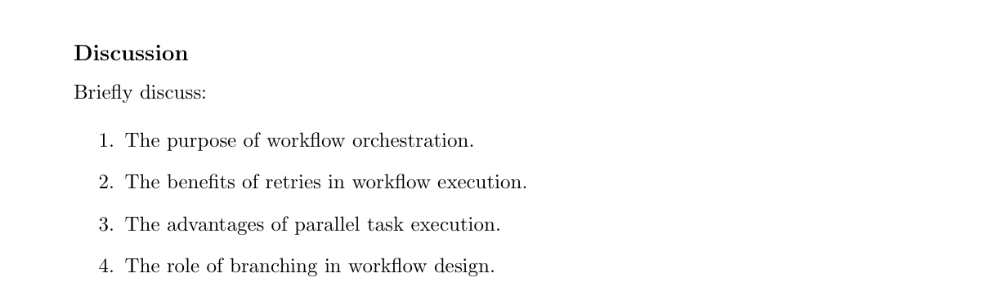
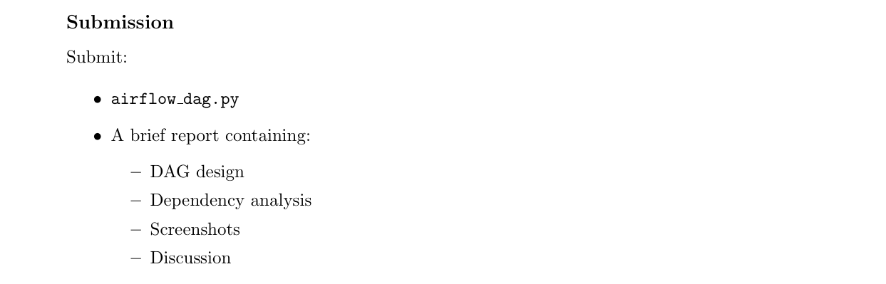

Workflow Tasks

DataGeneration + 2. DataValidation + 3. DataPreprocessing + 4. FeatureEngineering + 5. Analytics + 6. ReportGeneration
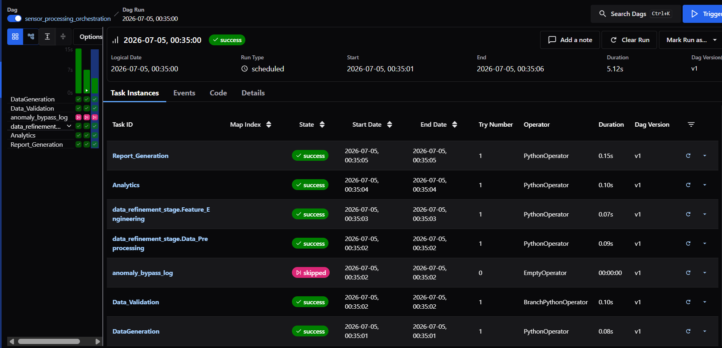

Requirements

1.Design an Airflow DAG + 2. Determine appropriate dependencies + 3. Tasks that can execute in parallel and implement parallel execution + 4. Atleast one TaskGroup. + 5. Configure retry policies + 6. Use a BranchPythonOperator + 7. Assign suitable priority weights + 8. Schedule the DAG + 9. Airflow UI
All requirements are being implemented in airflow_dag.py file

Airflow Report Requirements

1.DAG graph screenshot
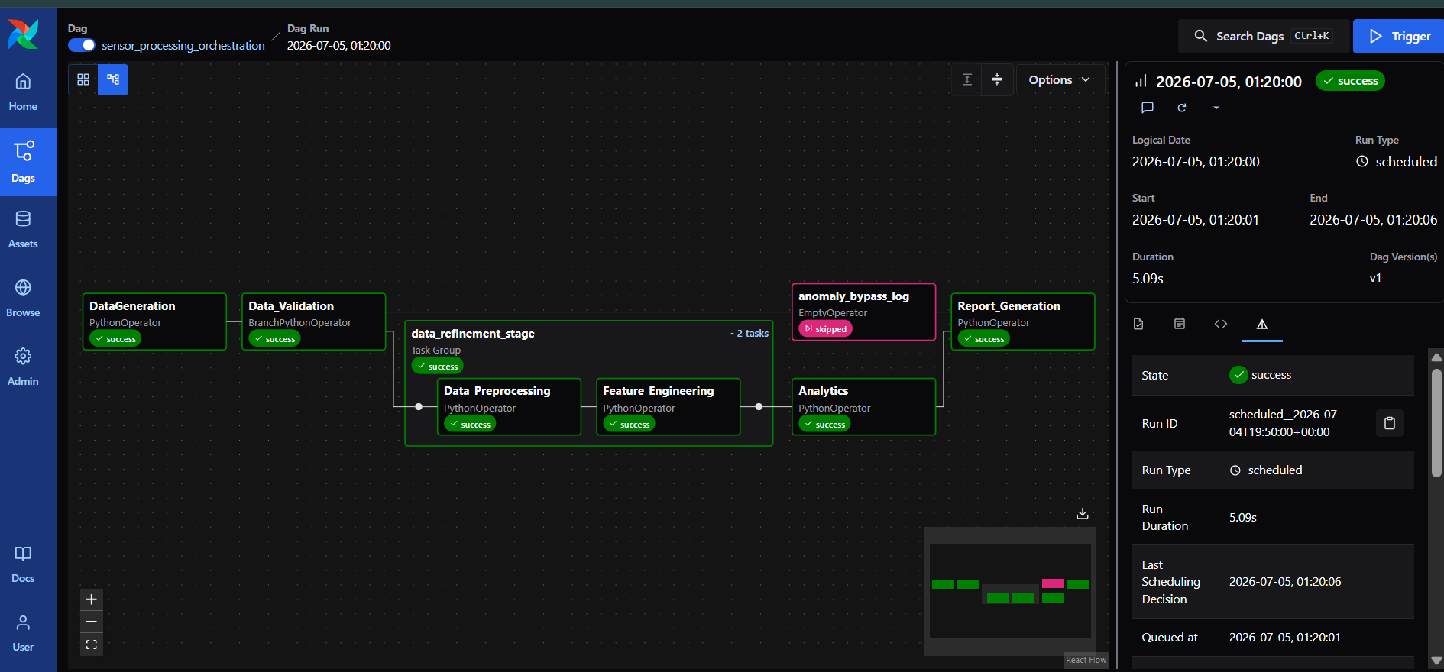

Description of task dependencies + 3. Explanation of parallel execution opportunities
- # ==============================================================================
- # DEPENDENCIES & PARALLEL EXECUTION OPPORTUNITIES
- # ==============================================================================
- # 1. Main Path: Data Generation flows immediately into Validation checking
- task_generation >> task_validation

- # 2. Branch Mapping: Validation dynamically selects the next execution target
- task_validation >> [data_refinement_stage, task_anomaly_bypass]

- # 3. Parallel Execution: Once the refinement TaskGroup finishes, Analytics
- # runs in parallel with any other isolated evaluation paths
- data_refinement_stage >> task_analytics >> task_report_gen

- # 4. Alternative Path: Anomalous track connects back directly into Report Generation
- task_anomaly_bypass >> task_report_gen

4. Branching behavior screenshot.

Data -Processing
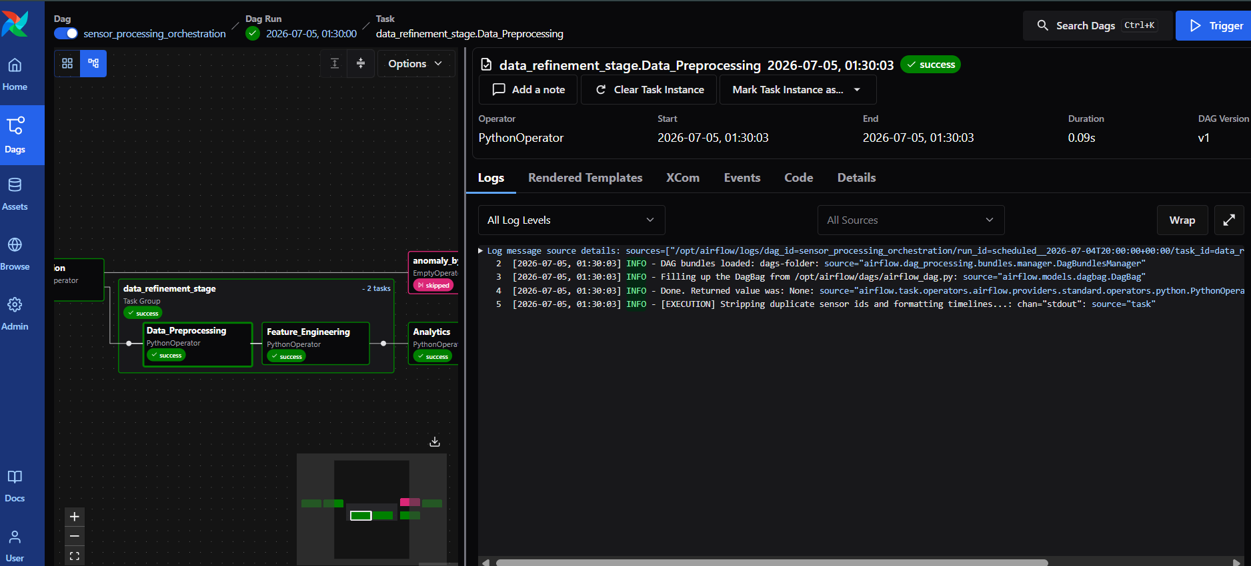
Feature Engineering
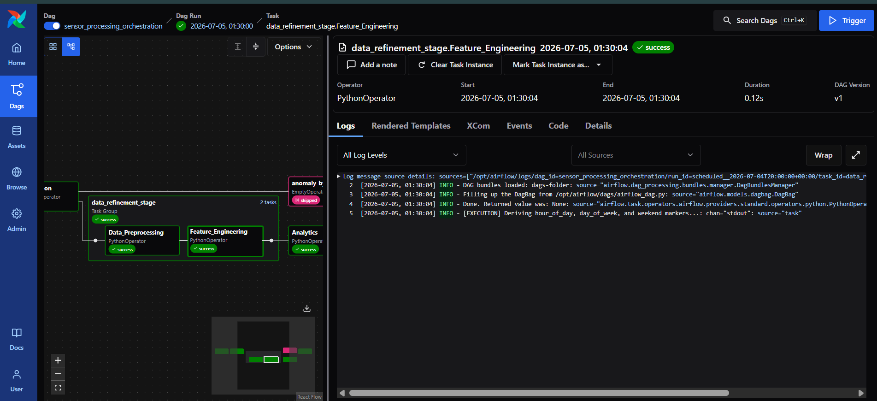

5. Retry execution screenshot
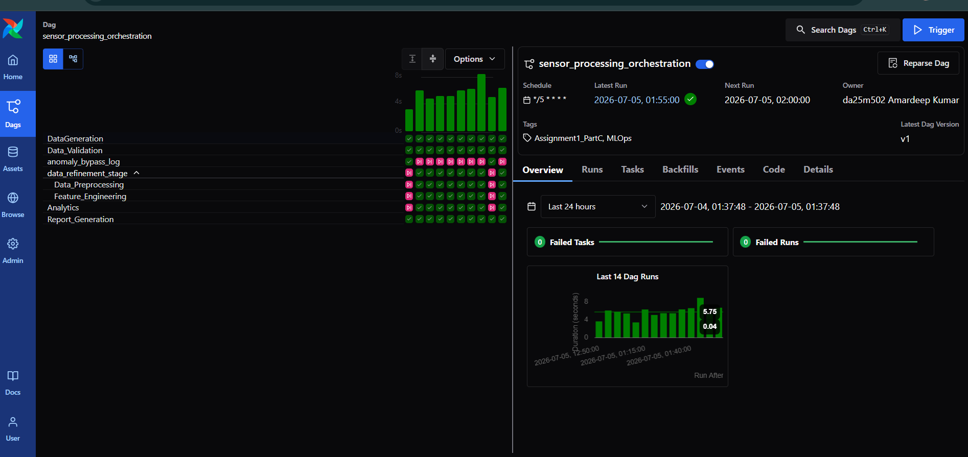

6. Task duration summary.
Data Generation
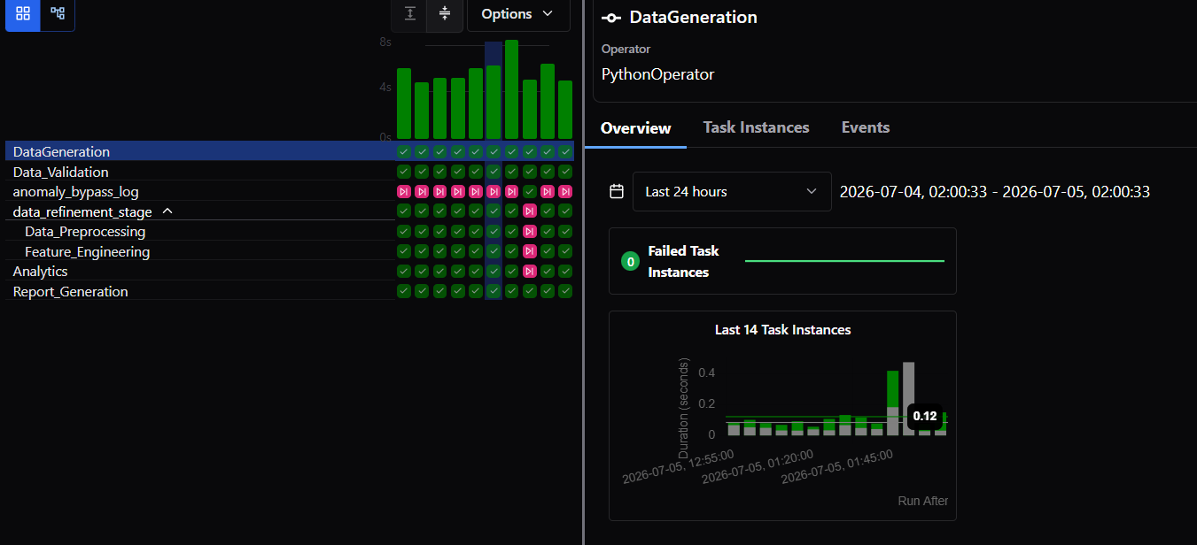

Data Validation
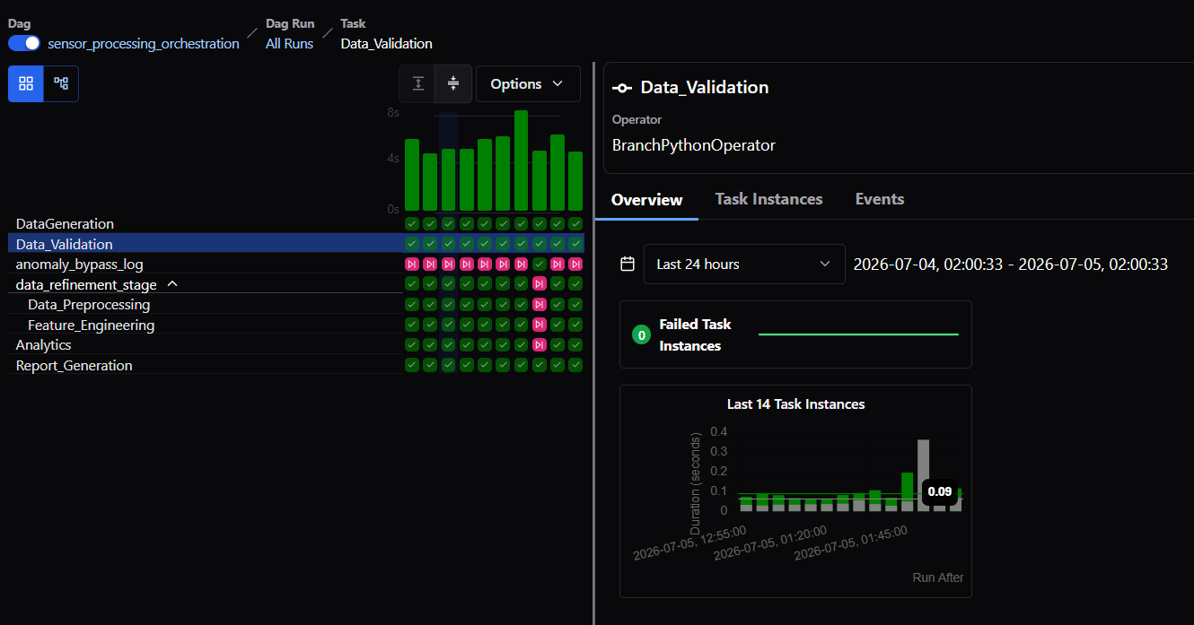

Data Preprocessing
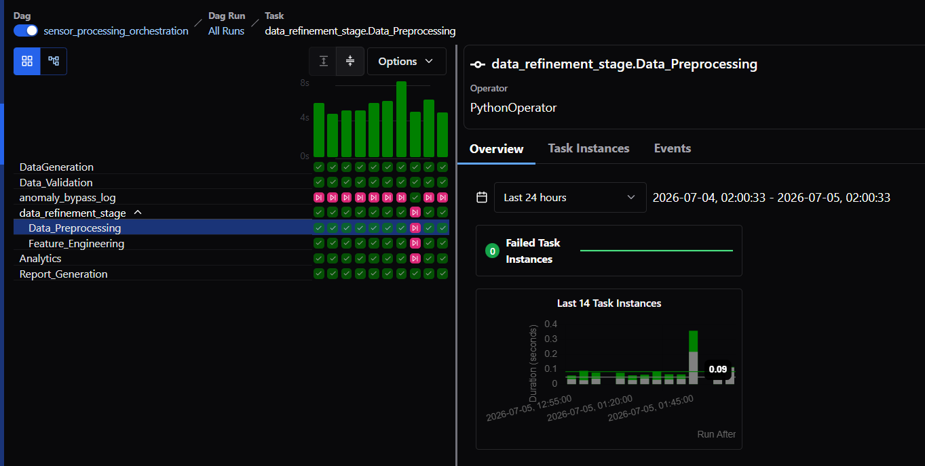

Feature Engineering
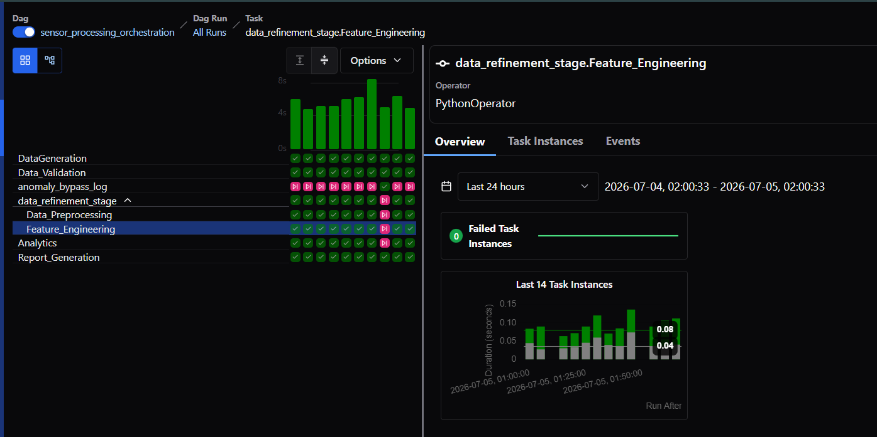
Analytics
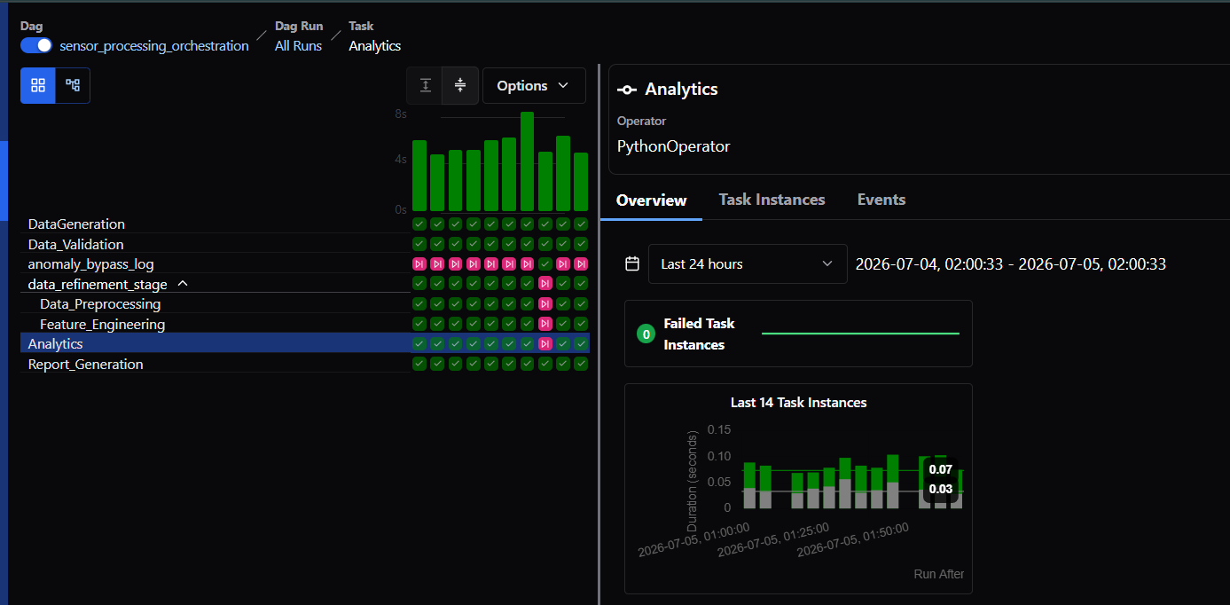

Report Generation
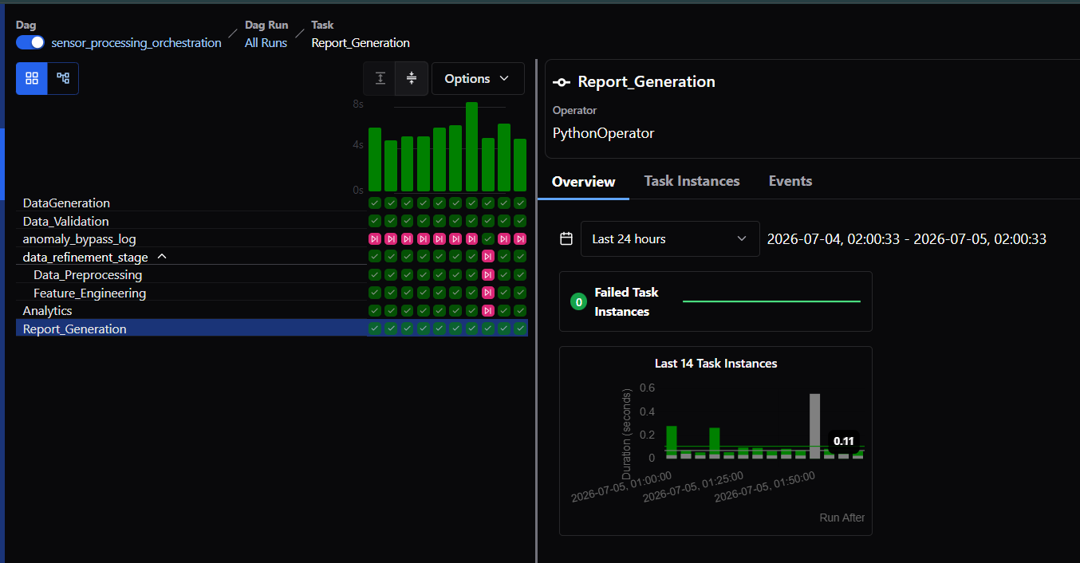

Discussion

1. Purpose of workflow orchestration
Workflow orchestration builds the full pipeline which gives a meaning to each sperate module or functionality. This directly help automation, builds complex data pipelines, easy the dependency management and make sure each stage in processes goes correctly as it was supposed to go.

2. The benefits of retries in workflow execution
There are multiple reasons for temporary failures where production MLOps pipelines can breaks due to network delay, havey operation timeout, some connectivity issues. Retries makes system fault-tolerance and reduces the manual intervention.

3. The advantages of parallel task execution
When MLOps pipelines execute where one task can be independent to another task in such scenario’s parallel execution makes the processing faster and give faster results by utilizing the optimal resource capacity as compare to sequential execution where task need to wait for executions.
Branching is one of the examples of parallel execution.

4. The role of branching in workflow design
When there is a conditional statement, decision making flows are present in those scenario’s branching comes where it executes the task based on given condition so in this not satisfying condition task gets skipped. This makes workflow cleaner by reducing the multiple pipelines requirements.

